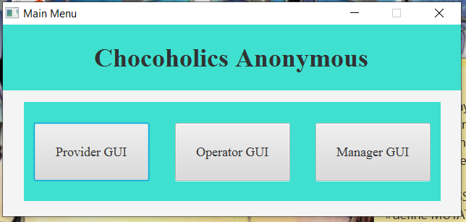

User Interface 87-89, 93-95

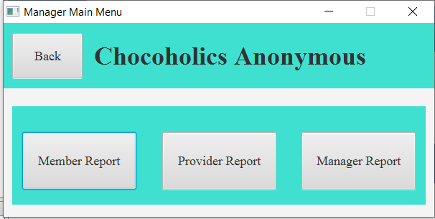

User Interface 77-79, 84-86, 92, 103

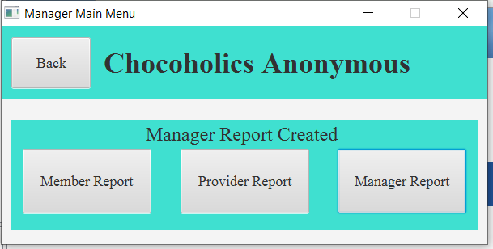

User Interface 99

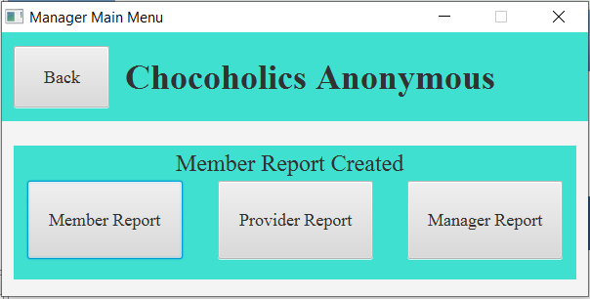

User Interface 97

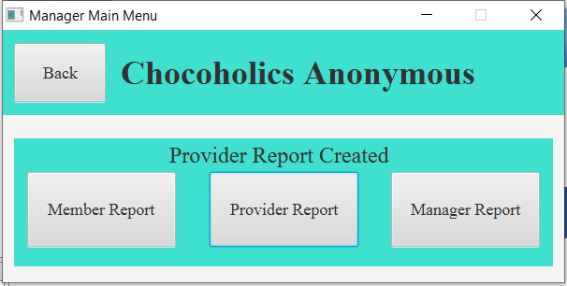

User Interface 98

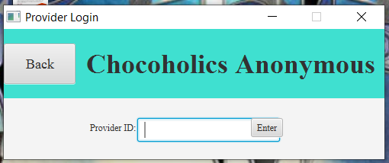

User Interface 90

Valid Data 2, 40

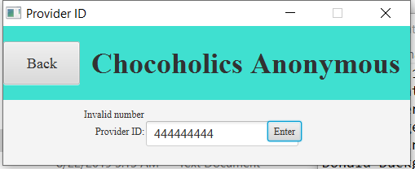

Invalid Data 1, 3

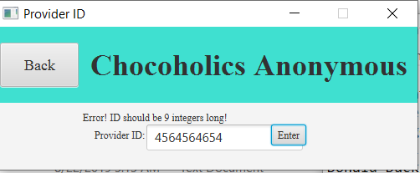

Invalid Data 8

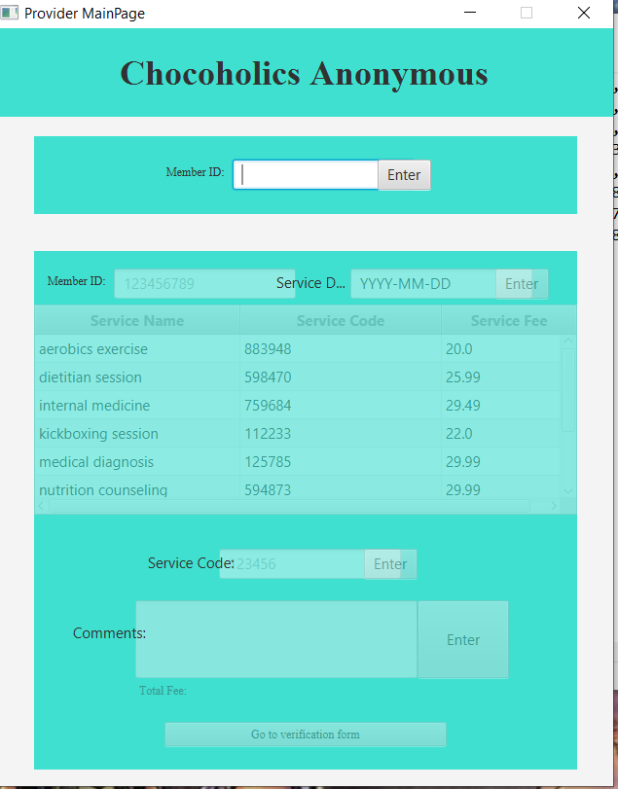

User Interface 1-10, 96

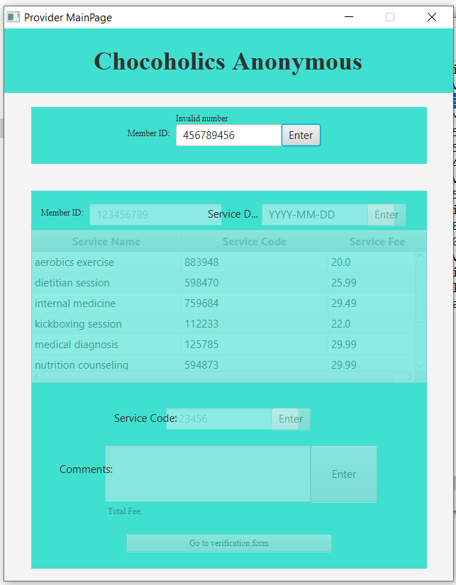

Invalid Data 2, 4

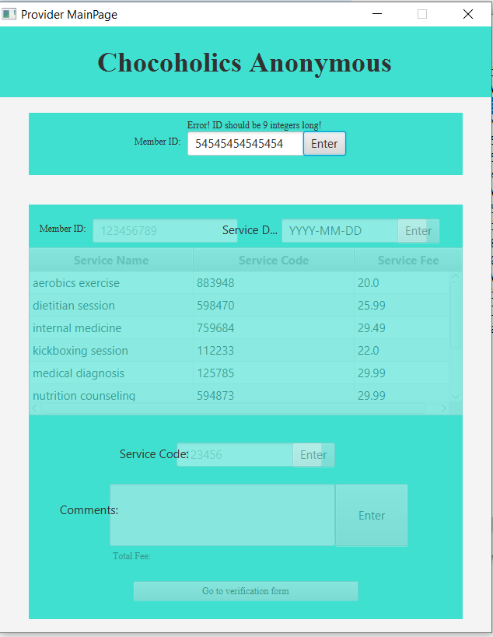

Invalid Data 9

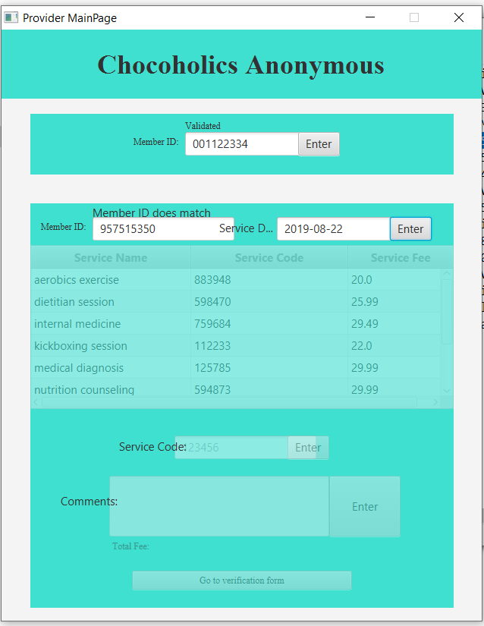

Invalid Data 10

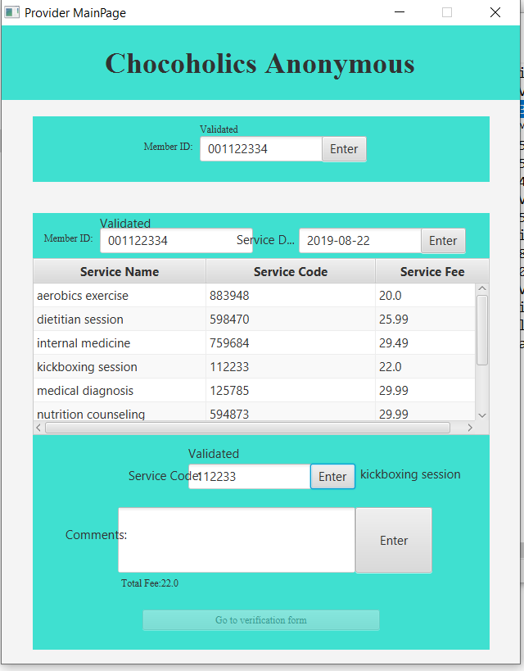

User Interface 11

Valid Data 4, 19, 41

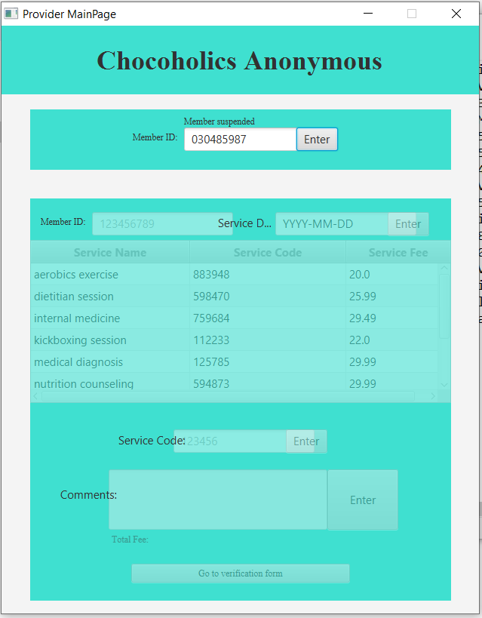

Valid Data 5

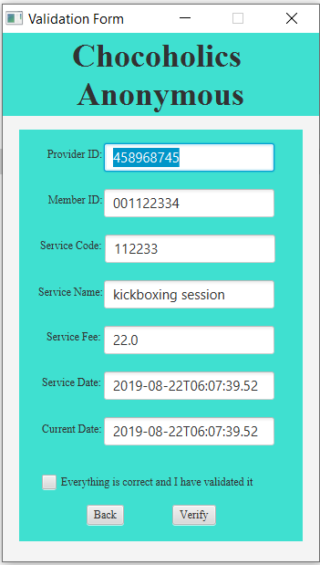

User Interface 100-108

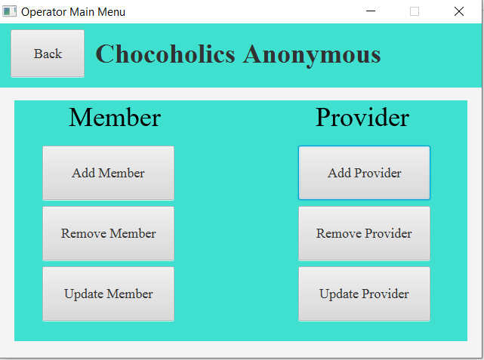

User Interface 12-17, 62, 63, 76, 80, 82, 83, 91

Valid Data 32, 33

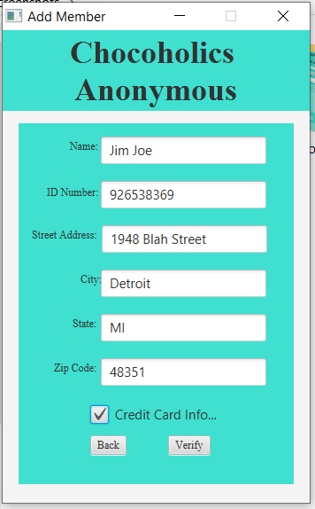

User Interface 18-24, 27-34, 36-38, 60, 109

Valid Data 24, 38

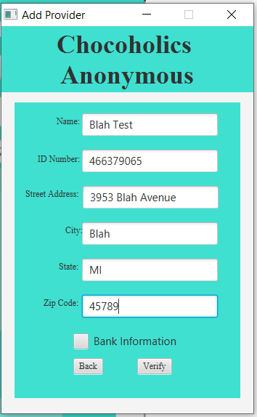

User Interface 39-40, 42-45, 61, 81, 112

Valid Data 25, 39

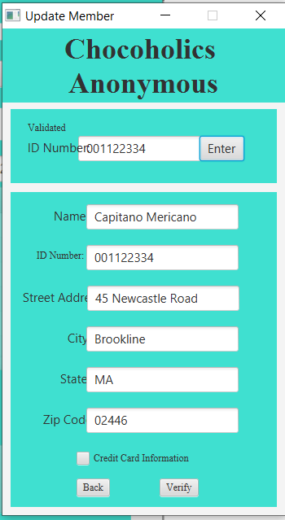

User Interface 48-53, 75, 110

Valid Data 26-28, 30, 34

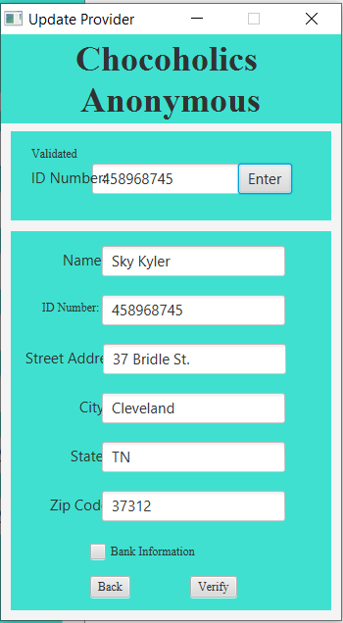

User Interface 54-59, 113

Valid Data 29, 31  
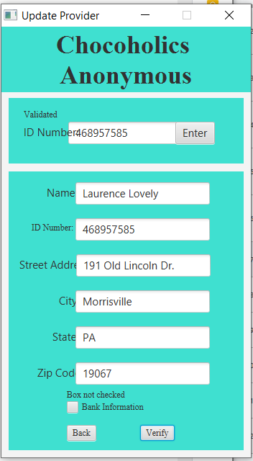

Invalid Data 19

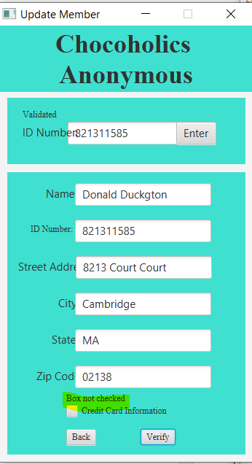

Invalid Data 20

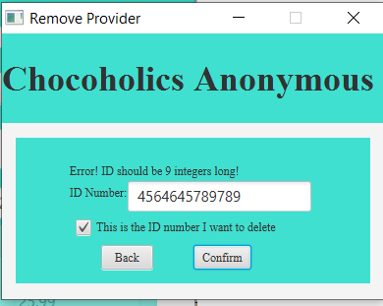

User Interface 72-74, 114

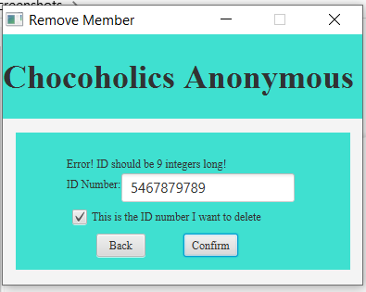

User Interface 64, 71, 111

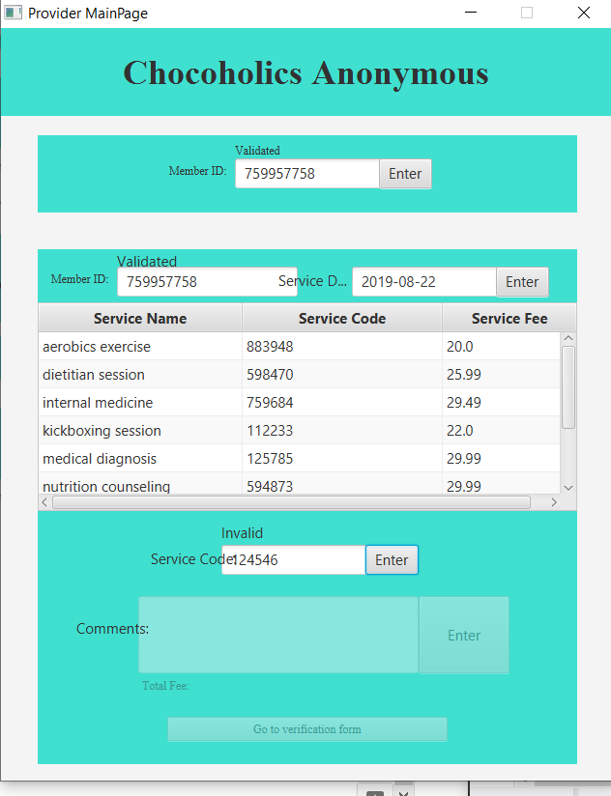

Invalid Data 7

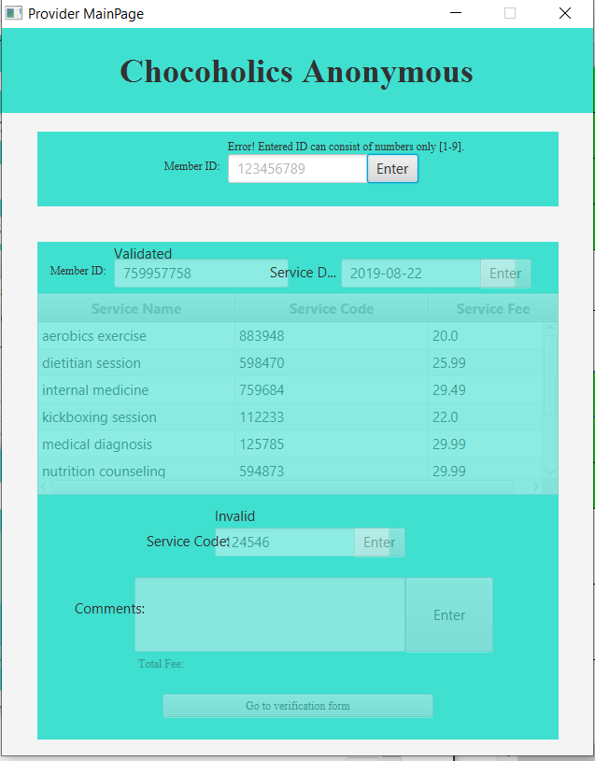

Invalid Data 5

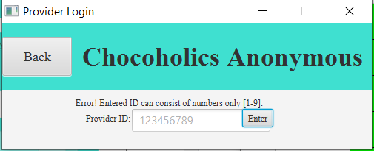

Invalid Data 6

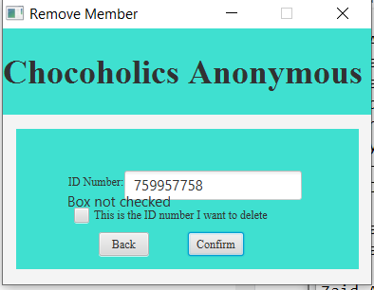

Invalid Data 14

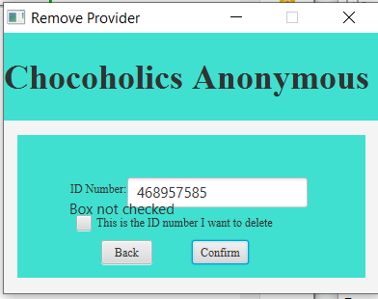

Invalid Data 15

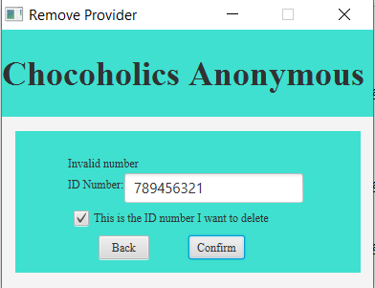

Invalid Data 17

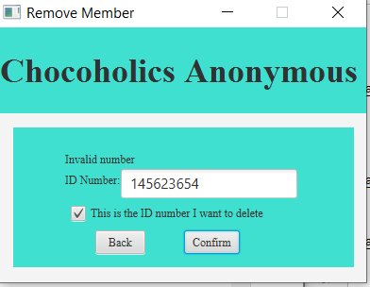

Invalid Data 16

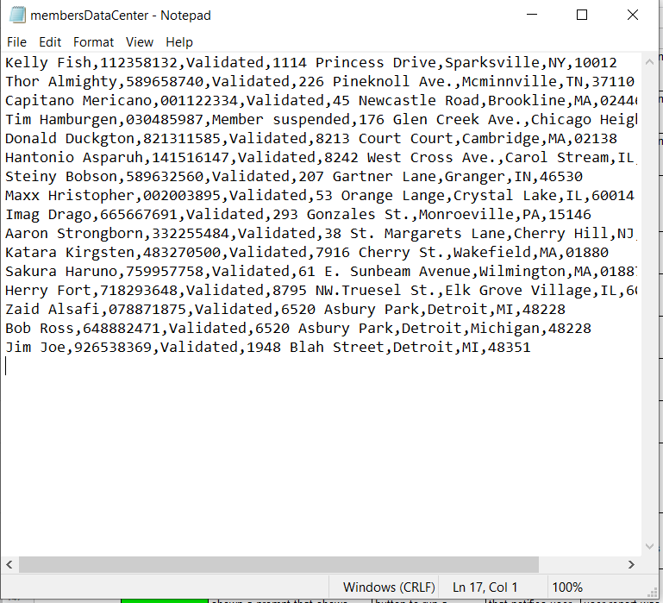

Valid Data 11, 20, 22, 35, 36

File Testing 1, 5, 6

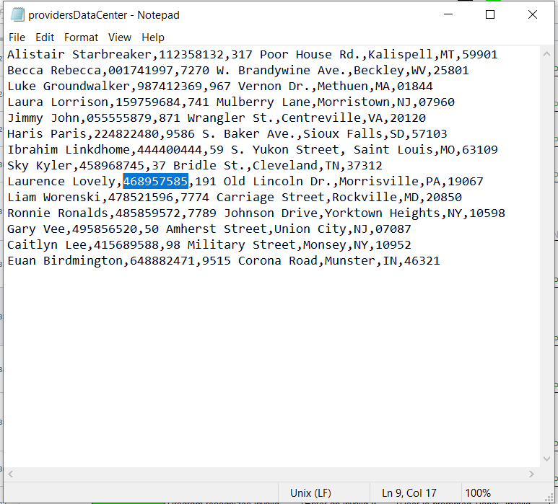

Valid Data 12, 21, 23, 37

File Testing 2, 7, 8

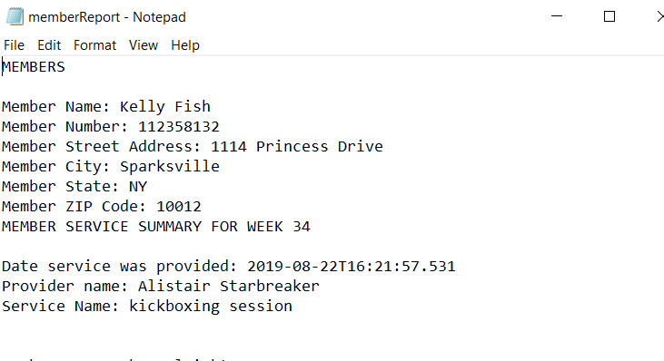

Exporting Data 8-15

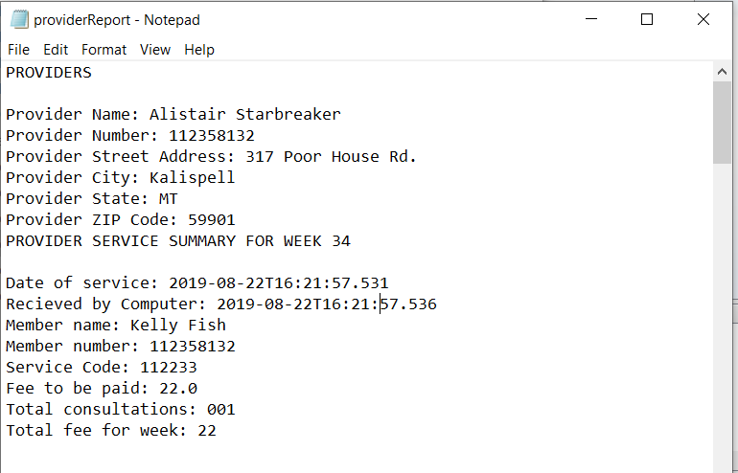

Exporting Data 16-26

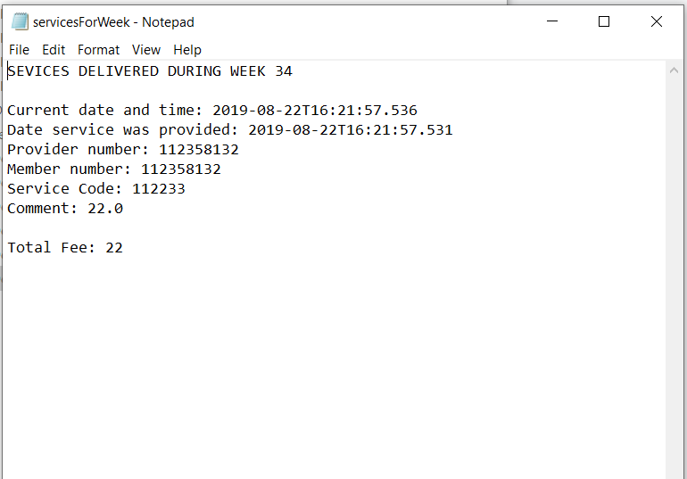

Exporting Data 1-7